MAPPING RECEPTION: THE HOGARTH ESSAYS SERIES
Kela Apau, Clark Honors College, University of Oregon (with Helen Southworth)
As part of my final project for a summer introductory Digital Humanities class (2017) at the University of Oregon’s Honors College (co-taught by MAPP’s Helen Southworth and Digital Mitford’s Professor Raisanen), Professor Southworth and I looked at the three Hogarth Essay Series (1926-1928, 1947; a compendium of selected essays was published in the US in 1928 by Doubleday Doran). We wanted to consider contributors to the series from a network perspective –asking were they all Bloomsbury/how were they connected to the Woolfs?--and to draw some conclusions about topics treated over time. We also wanted to know who had bought and read the books in the series, which numbered 36 titles in total, where they had been sold and where they had traveled.
The Hogarth Essays are short, pamphlet-like publications. They are relatively flimsily made, priced from 2s 6d for essays of approximately 20 pages to 3s 6d for those of 40 pages, (s are shillings and d, pence), with J.M. Keynes’ and Rose Macaulay’s contributions interestingly selling for just 2s (Woolmer). We hypothesized that, like magazines of the period, many may have been lost to time and to moths. We’d read several chapters from Robert Scholes and Cliff Wulfman’s How to Read a Modernist Magazine and had visited Special Collections to inspect first editions of modernist magazines for ourselves. Several of the University of Oregon’s library copies of the Hogarth Essay Series that we looked at, some of which remain in the stacks, had had their covers removed and were in relatively poor shape.

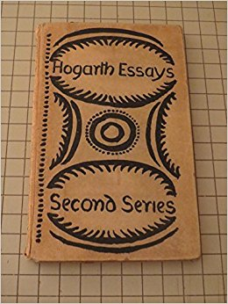

(Composition as Explanation, Gertrude Stein, Amazon)

Here are some of the diagrams I generated using Google Fusion Tables pertaining to topic distribution and networks of authors. I used data and genre labels from J.H. Willis’s Leonard and Virginia Woolf as Publishers: The Hogarth Press, 1917-41, as well as other books about the Press and the Woolfs, and Wikipedia. I used binary categories such as involvement in the Bloomsbury Group, author nationality, genre of work, and World War I participation to visualize possible connections between authors. Willis’s genres allowed for easier comparison between works. I used binary categories and the first occupation and genre that Wikipedia listed because Google Fusion Tables constructs webs best with single value entries even though many of the individuals and essay topics overlap with other fields of study and work.

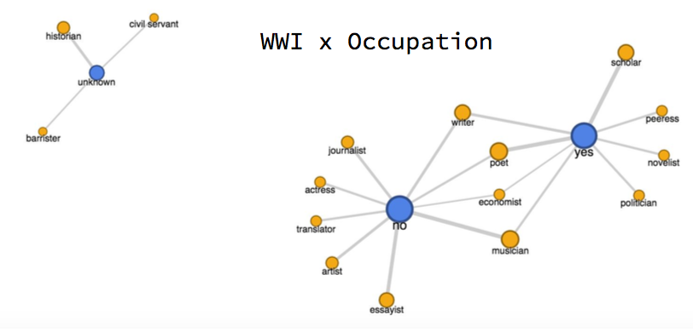

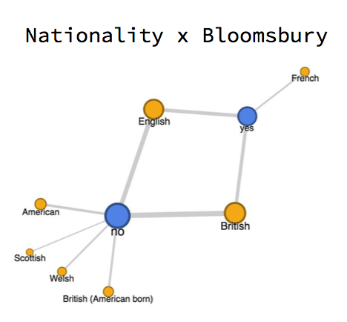

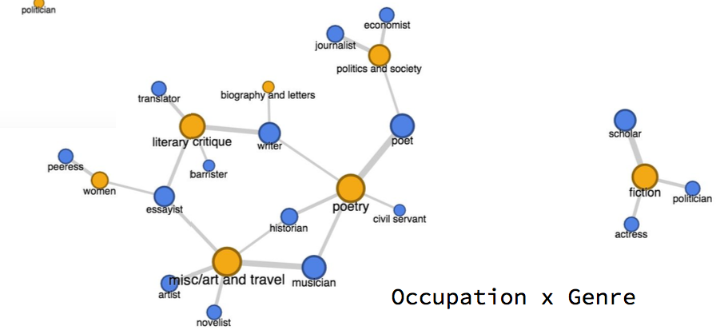
In order to track former owners, Professor Southworth and I crowd-sourced information from online booksellers at AbeBooks, Amazon and Ebay, who were very generous with information, as well as a few Hogarth Press collectors. (Thanks to Stuart Clarke and Stephen Barkway!). We also looked at extant copies using library catalogues WorldCat and COPAC and contacted libraries for information about inscriptions or donation information. We did not have access to names from the University of Sussex ledgers about buyers from which J. Howard Woolmer culls numbers of copies printed included in his Checklist to the HP. The University of Reading order books currently available at MAPP did not cover the titles we explored.
I used Silk to display the data by creating a “data card” for each essay with print and distribution information, a picture of the cover (if available), and previous ownership information (again, if available). The website tool was great for a blogging novice because it organized the data into collections and graphs.
The booksellers and libraries provided us with ownership information. They also gave us geographic data if we hypothesized that books sometimes remain in the locale where they were purchased. (We acknowledge that this might not be the case with some of the very collectible Hogarth Press titles.)
I initially wanted to focus on just one title, Leonard Woolf’s Fear and Politics: A Debate at the Zoo (1925). A political allegory involving animals, this work preceded George Orwell’s much better known Animal Farm by 20 years (1945). We found little in the way of reception of the work and information on only one copy donated by Elise Steyne Untermyer to Smith College as part of a collection of several other Hogarth Press titles (Woolmer says only 251 of 1000 copies were sold). Smith College archivist Karen Kukil provided us background on Elisa Nina (Steyne) Untermyer a Smith College alumna (cum laude A.B. 1919) who donated several Hogarth Essays, including: Fear and Politics, Henry James at Work (Theodora Bosanquet), Homage to John Dryden (T.S. Eliot), and The Artist and Psycho-Analysis (Roger Fry) in 1947. Steyne frequently contributed to the Smith College Monthly 1918-1919 and graduated cum laude with an A.B. in English and German minor.

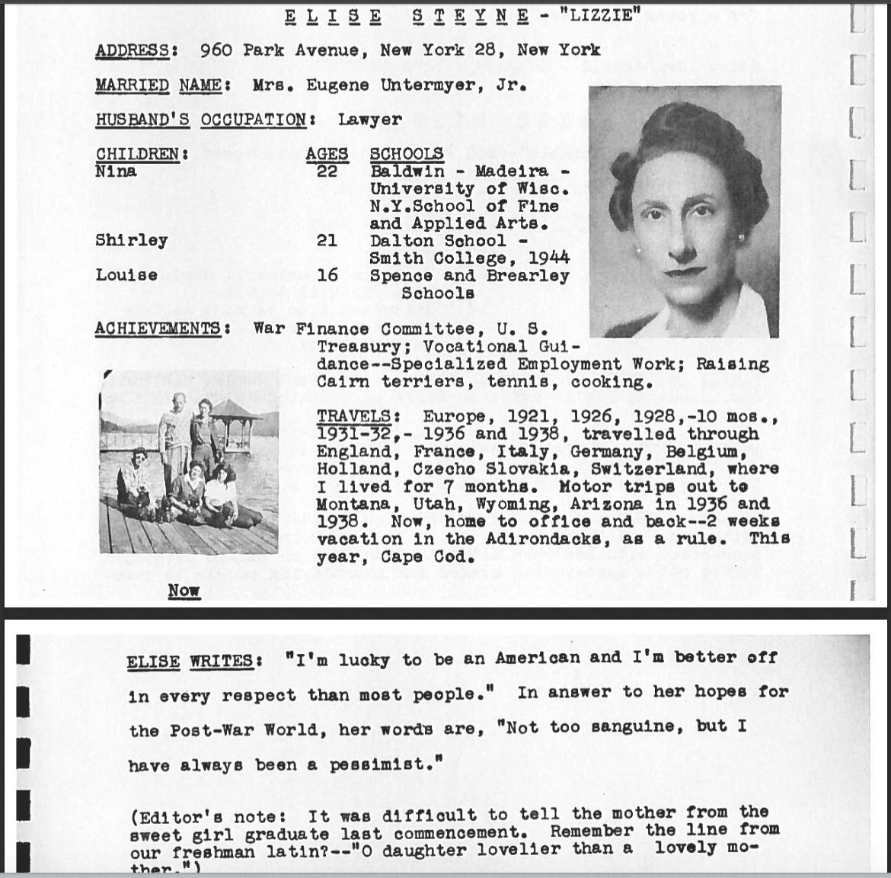
(Karen Kukil, Smith Special Archives)

Given the limited information we could find about Leonard Woolf’s title, we decided to expand our focus to the entire series. Here’s a taste of what we found:

One copy of Virginia Woolf’s own Mr. Bennett and Mrs. Brown, the inaugural title of the first series, held the inscription ‘J. Simmons 01/27/41’ and had been purchased at Sylvia Beach’s Shakespeare and Company (see Josh Kotin’s wonderful Shakespeare & Co site: Mapping Expatriate Paris). We guessed that this was possibly Isabel Simmons (an ‘I,’ not a ‘J’), friend of Ernest Hemingway, himself, of course, a haunter of Sylvia Beach’s Paris-based expatriate bookstore. Another copy bore the name Phyllis Bentley and included a few notes. Bentley (1894-1977) was a Yorkshire-born novelist, a contemporary of Virginia Woolf, best known for the Inheritance trilogy. We located yet another copy in the collection of John Buchan (1875-1940) (Thirty-Nine Steps author and Canadian Governor General) at Queen’s University in Canada.

Roger Senhouse (1900-1970), Colette translator and friend to French novelist Jean Genet, bought Roger Fry’s The Artist and Psycho-Analysis. Senhouse, a younger generation Bloomsbury Group member, was lover to Lytton Strachey and became head of/partner in the publishing company Secker & Warburg.

American poet and publisher James Laughlin (1914-1997), founder of New Directions publishing (in 1936), owned Robert Graves’ On Impenetrability or the Proper Habit of English.
We found a copy of T.S. Eliot’s Homage to John Dryden with a dedication to his mentor, poet George Saintsbury, for sale for $67,500. A second copy belonged to James M. Hall, emeritus professor of English and Dryden specialist at the University of Cincinatti.

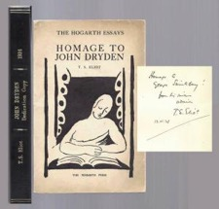

(TBCL: The Book Collector’s Library)

Barrister C.P. Sanger, himself a contributor to the Hogarth Essays with The Structure of Wuthering Heights and Bloomsbury Group intimate, owned Graves’ Contemporary Approaches to Poetry.

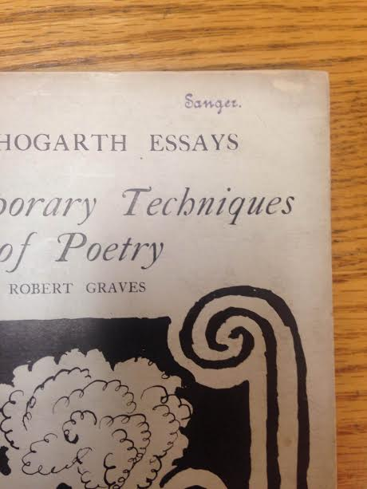 (Bill Montague, Fahrenheit Books)
Actress, writer, and suffragette Elizabeth Robins had dedicated her Ibsen to the Bloomsbury Group’s Desmond MacCarthy.

Cambridge University had two copies of John Maynard Keynes’ A Short View of Russia. One of the copies was received by the Library from the Hogarth Press under the terms of the Copyright Act of 20th August. The other was part of a collection of John Maynard Keynes’ brother Geoffrey Keynes’ books.

Lesser known owners or ‘common readers’ included:
Edgar F. Harden, a former Professor of English at Simon Fraser University in Vancouver, Canada, purchaser of Theodora Bosanquet’s Henry James at Work,
an unidentified Margaret Rieser, purchaser of Gertrude Stein’s Composition as Explanation in 1933.
Ian Prentice who bought Robert Hull’s Contemporary Music
. . . and we found the same title by Hull dedicated “To Peter from Russell” . . .

Some very tentative conclusions include that the series on the author side primarily included those familiar to Bloomsbury and to the Hogarth Press. Although many of the readers we found were famous and part of, or tied to, Bloomsbury—this perhaps a reflection of the value of books owned and signed by the likes of T.S.Eliot—we did find a fair number of common readers.

Investigating the Hogarth Essays series by charting the evolution of the series, designing network maps between authors, and investigating previous owner inscriptions allowed me to better grasp the series’ global impact and to learn that medium inherently affects perception. MAPP’s emphasis on publication and dissemination and the underlying connections with esteemed friends and burgeoning authors intrigued me because I have never extensively focused on the socioeconomic context of literary material. The author and owner networks and distribution charts showed the Woolfs’ illuminating their public with inexpensive and current reading material in a way that might not have been quite as apparent without graphical presentations. I gained a greater understanding, and a healthy respect, for the visualization tools and computational analysis that DH projects contribute to the humanities and society.

